Prepopulate Primary Contact Field in Opportunity When Lead is Converted

1:Make Checkbox field type in Opportunity leaved Unchecked

* 1. Make another Checkbox field in Lead leaved Checked
  2. In Lead Go to Field and relationship properties then select field mapping select opportunity tab map the checkbox field of lead.

2:Make Recorded Triggered flows In Start element select Opportunity Object in Configure trigger Select Record create & update.

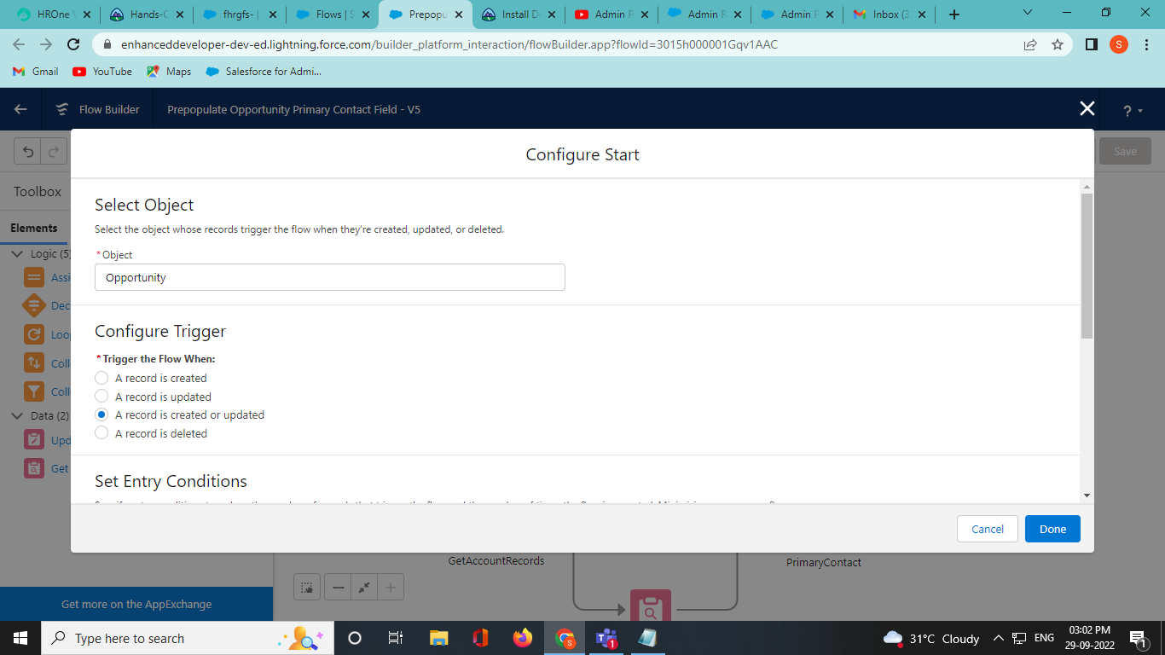

2.1 : Optimize flows area Select Before Trigger which Fast field update option click done.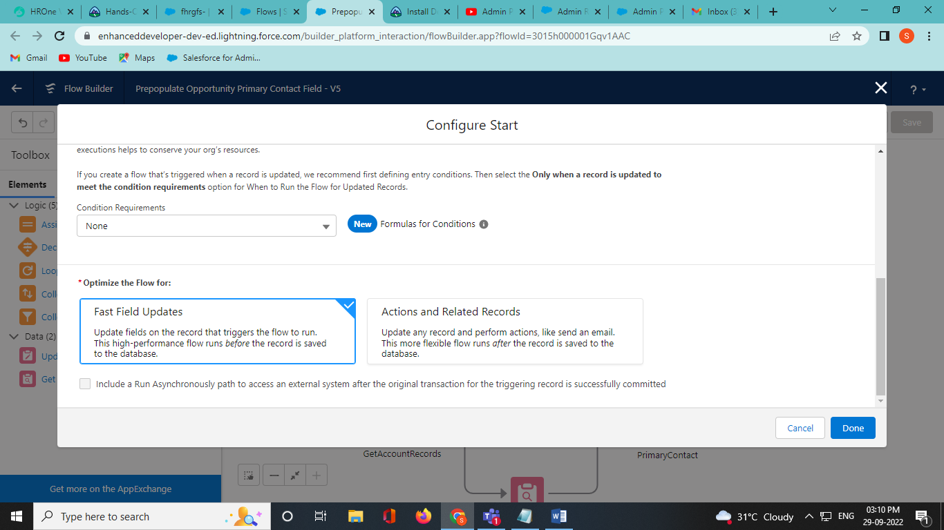

3:Take a decision element to check that the checkbox fields in opportunity isOpportunity = True; click done.

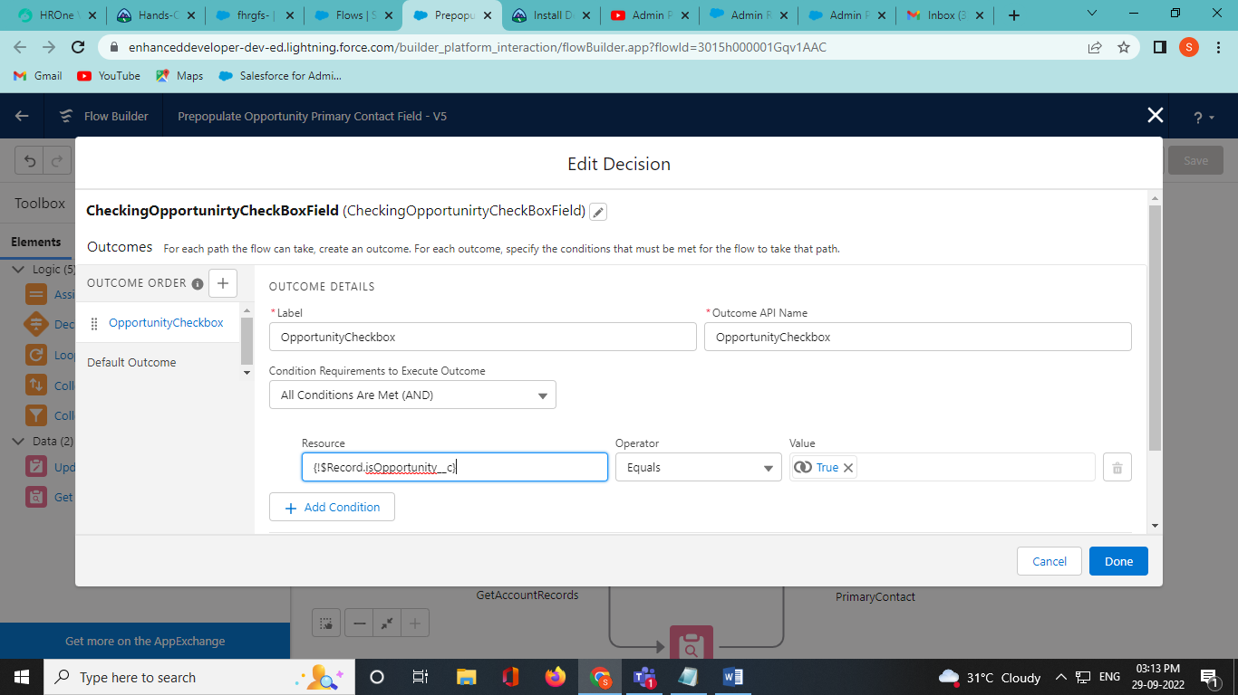

4:Then to get Account records select Get Records Element,select Account object and in condition we check

Id = RecordOfAccount.AccountId

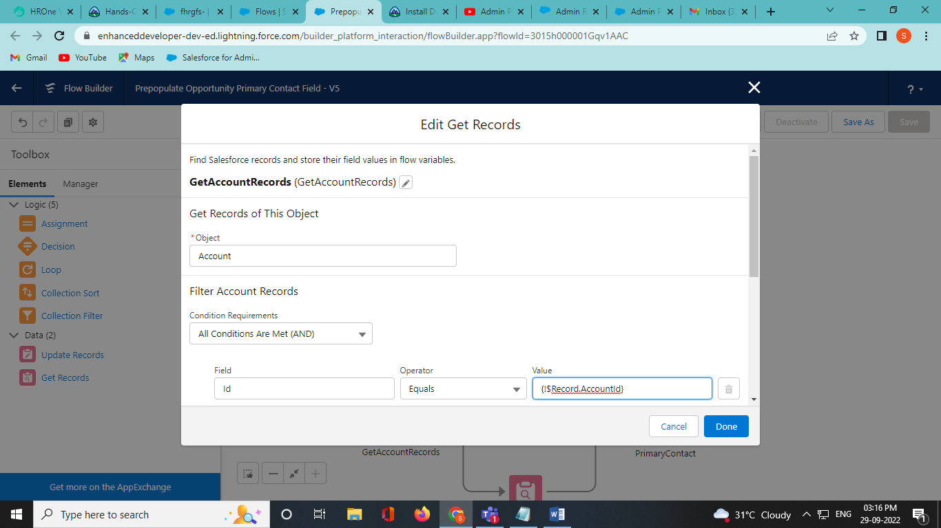

5:To get contact details select Get Record elements and then Select Contact object and check that AccountId = getAccountRecords.id

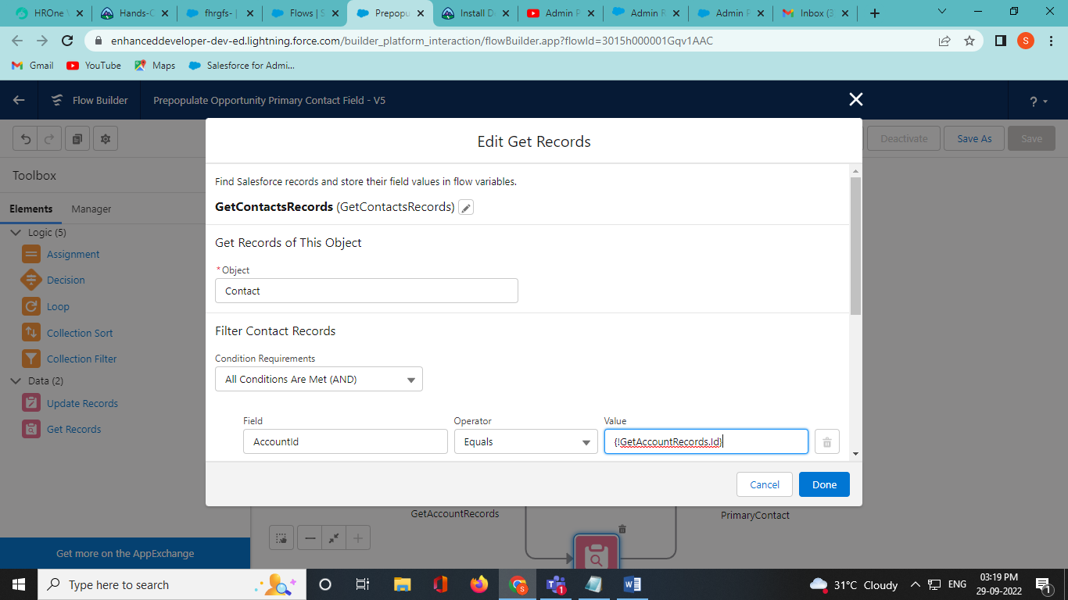

6: At last take assignment element to assign primary contact then check

RecordOfOpportunity. Primary_contact__c = getConatctRecords.id

